CS625 - Professional Practices.
BSCS | Pakistan.
Finalterm Current & Past Papers Spring 2025.
7 - 16
2025
- MCQs.
- Around 95% MCQs from [ BSCS / Hina Shehzadi / AK ] & Ayesha Batool Files.

- Short Questions.
- Three Copyright law gives exclusive rights to the owner of copyright.
- Contracts for the supply of Custom-Built Software at a fixed price consists of three sections. Enlist the sections.
- Three general categories of controls (Risk Control Strategies).
- Nowadays, computer-controlled systems are to be found in a wide range of diverse applications. Enlist three names of application.
- Two methods of Password [ Hacking / Cracking ].
- Two categories of infringement of contracts.

- Long Questions.
- Five Factors affecting system safety.
- What should do after hacked?
- Which of the following are the advantages of the internet?
- The internet provides a vast array of entertainment options.
- The internet has created new opportunities for cybercrime.
- The internet has made it possible for people to work from home or remote locations.
- The anonymity of the internet has made it easier for people to engage in cyber bullying, harassment and hate speech.
- Related to cyberbullying.

------------------------------------------------------------------------------------------------------------------------------------------

MCQs 2024 [ Ayesha Batool ].
Circumstances that have potential to cause loss or harm is:
- Threat

Which contracts are used to assess some aspect of an organization and to make proposals for improvements?
- Consultancy

In Brute force, Hackers try out all the _____ letters.
- combination of keyboard

How to Protect Your Self from cyber-attack.
- Use caution when you click link

_______ is a common ethical issue on the internet.
- Privacy

Accessing a computer without the authorization of the owner
- Computer hacking

Intentionally entering false data or amending data into the computer.
- Input frauds

The process of attempting to gain or successfully gaining, unauthorized access to computer resources is called _____.
- hacking

One of the main concerns associated with a product mission critical application is?
- Safety and Reliability

Defamation is the _____ of information.
- misuse

Facebook and MySpace are open to people _____ and older.
- 13

_______ is a moral issue.
- Plagiarism

Regulation is concerned with?
- Rules and Directives

Sudden unwanted changes in the look and execution of an application are called which type of hacking?
- Software Hacking

A program that automatically detects security weaknesses in remote host.
- Scanners

Risk Assessment is:
- Assessing Potential Loss

The hardware or a process used in its manufacture may be protected by a _____.
- patent

The look of the product may be registered in the _____.
- Designs Registry

Information security, sometimes shortened to _____.
- InfoSec

Product liability and the Consumer Protection Act ensures that the manufacturer is liable for damage in _____.
- product

One of the common factors in failure of system safety is _____.
- people

After acceptance of the product the warranty period is of how many days?
- 90

Penetration testing methodologies
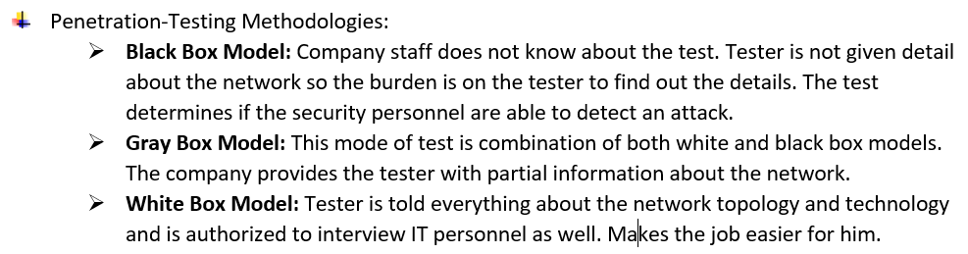

Intellectual property rights
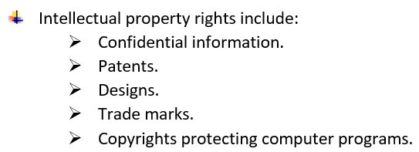

Software contract consist of:
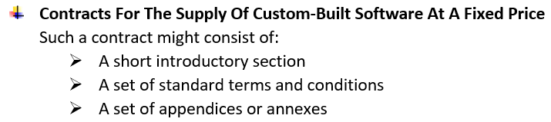

Computer Hacking
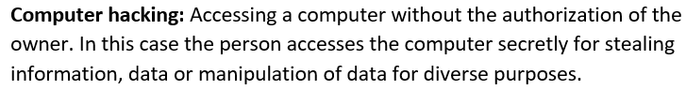

What we should not share on the internet

Product liability and negligence...also their examples
Products Liability:
Product liability is the area of law in which manufacturers, distributors,suppliers and retailers are held responsible for any injuries products cause.
Regardless of any contractual limitations of liability, if a product or any of its component parts are defective its manufacturer may be liable for damage under the Consumer Protection Act (CPA) or the common law of negligence.
Example: A medical device crashes due to a known software bug, causing patient harm. The vendor is liable for selling unsafe software.
Negligence:
The manufacturer or system designer has failed to take due care in the construction or design of the system, and this lack of care has resulted in failure leading to the injury.
Example: A company made a chair with weak legs. They didn’t check it properly. The chair broke, and someone got hurt.

Risk Assessment
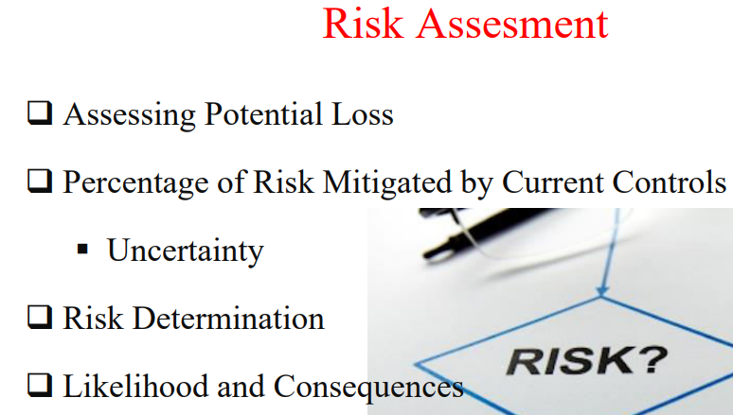

Three hacking tools
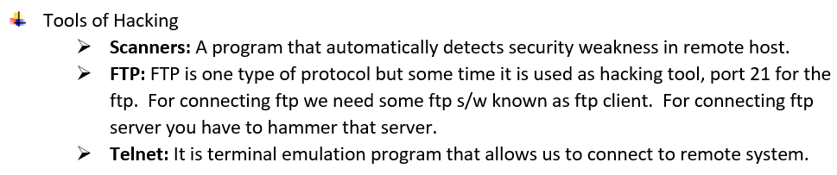

Two types of Software Contract
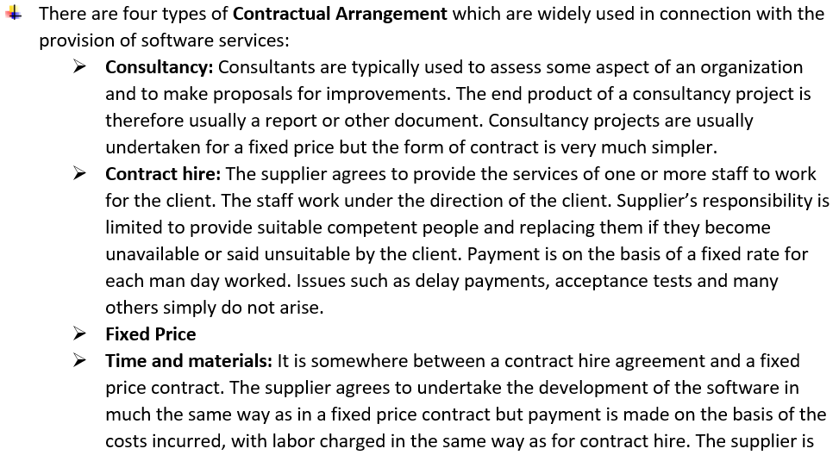

GATT concerned with the intellectual property rights of which software product?
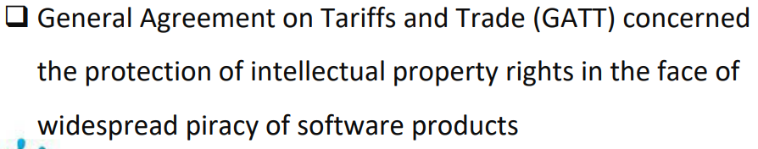

Risk Control Strategies:
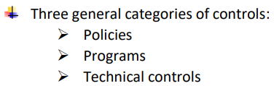

Types of Fraud (Computer Fraud Categories): ye di howi thin age likhna tha k out put input program fruad wagera
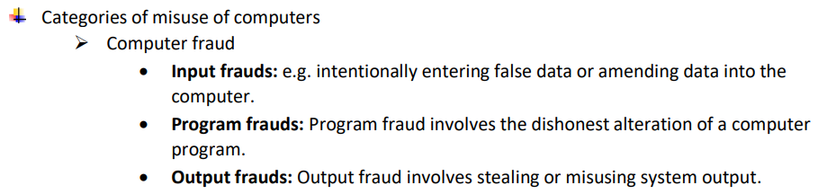

bki ek ambiguity software se related question tha
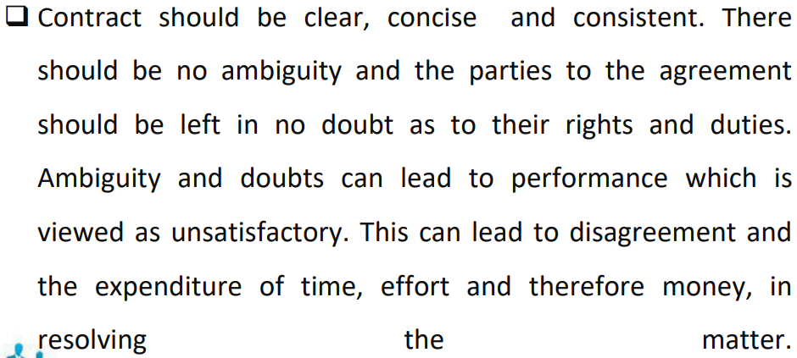

Or aik main likelihood ki statement choose krni thi
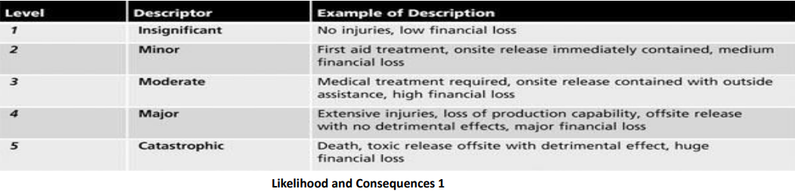
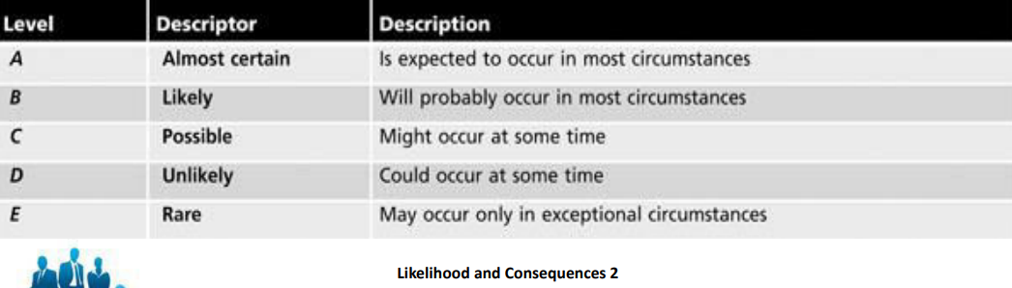

Internet k disadvantages batne thay 4 point given thay un m s
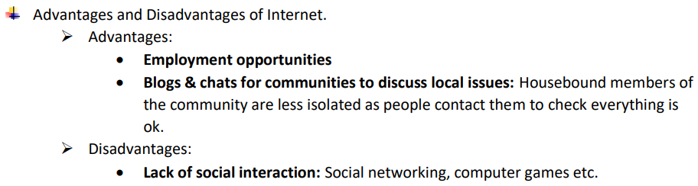

contract hire k tha ak question
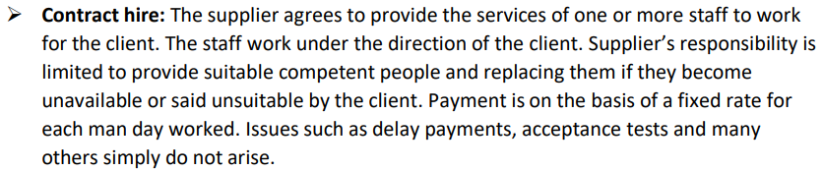

Factors affecting systems batane thy 5
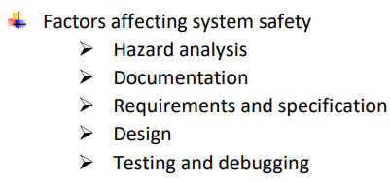

Moral Issues
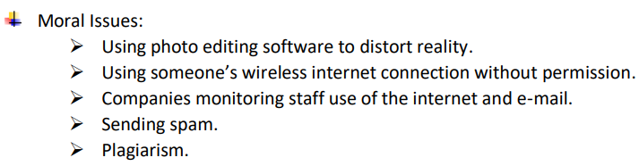

Types of hacking
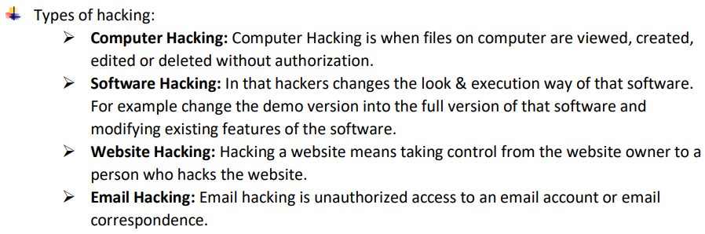

Ethical Issues
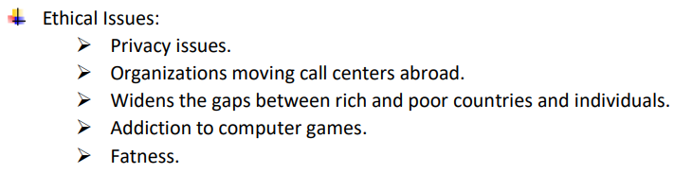

Main components risk management
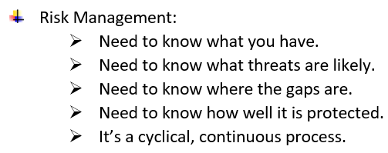

2 statement thi us mai btana tha exclusive knsi h or non exclusive knsi h
Exclusive: A license that grants only one person the right to use the copyright
Non-Exclusive: A license that allows multiple people to use the copyright simultaneously.

How crimes increased by use of computer
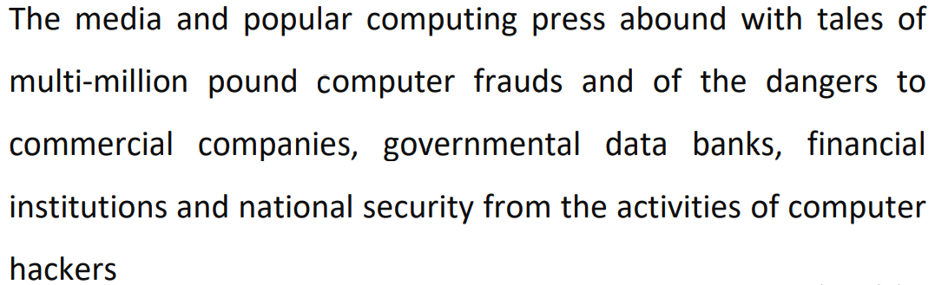
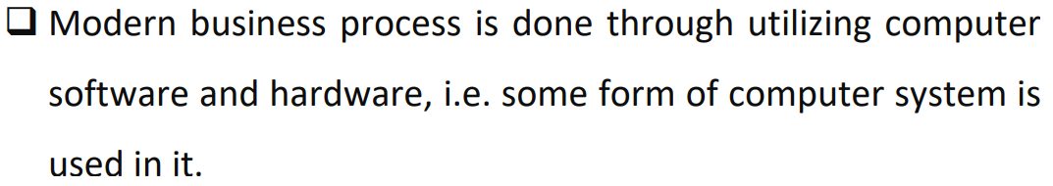
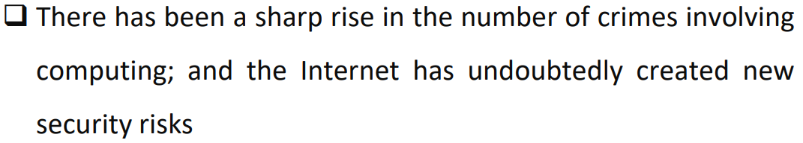

3 Copyright Laws
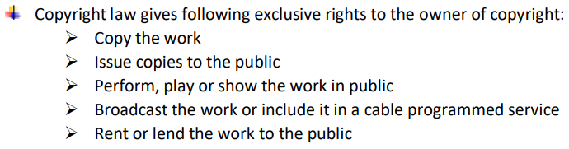

information security organizational structure (2 basic workers name)
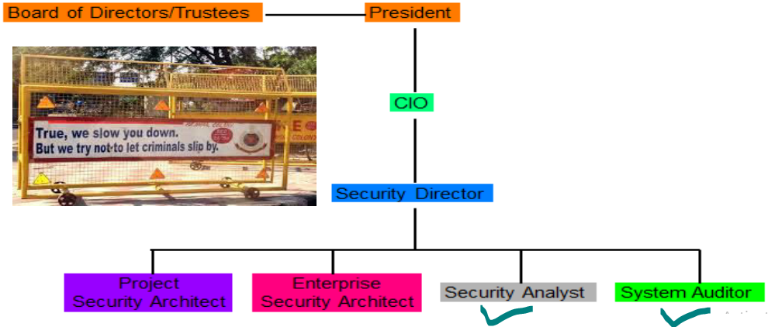

Types of social networking sites
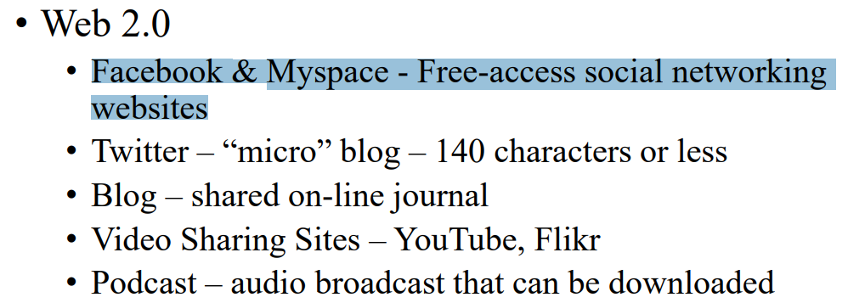

Types of Computer Fraud: (Input frauds, Output frauds, Program frauds).
Consider the given examples and identify the types of computer fraud:
1. Making a crack into Microsoft.
2. Email bombing.
3. Inserting a virus into the server.
4. Stealing money from online banking.
5. Obtaining WiFi password from unauthorized resource.
- Making crack into Microsoft
  - Type: Program fraud
  - Reason: Cracking software involves modifying or tampering with the program’s code or logic.
- Email bombing
  - Type: Input fraud
  - Reason: This involves repeatedly inputting data (emails) into a system with the intent to overload it.
- Inserting a virus into server
  - Type: Program fraud
  - Reason: A virus alters or disrupts program logic and execution.
- Stealing money from online banking
  - Type: Output fraud (can also involve input or program fraud depending on method)
  - Reason: If the attacker manipulates transaction outputs or intercepts the final data (like transaction confirmations), it can be considered output fraud. If they use false input or software manipulation, those may also apply.
- Obtaining WiFi password from unauthorized resource
  - Type: Input fraud
  - Reason: Illegally retrieving authentication input (password) to gain access to a system.

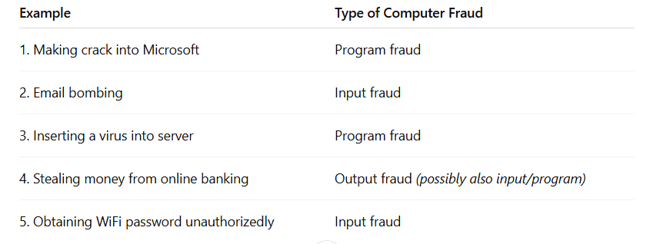

What should do after hacked?
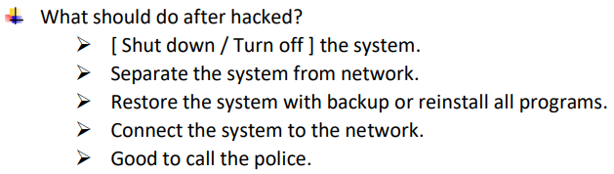

Five Hacker Creeds
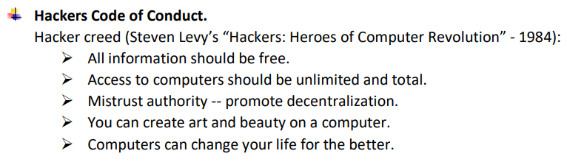

You are required to fill Column B against Column A in the following table.
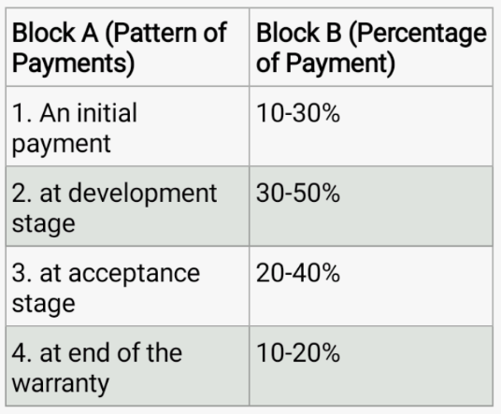

From the following which information should not be shared?
a. Personal Information
b. CNIC No.
c. Phone No.
d. Memes and Jokes
e. News Article
- Personal Information
- CNIC Number
- Phone Number

Evaluate the impact of spreading defamation on digital platforms?
- Even when people don’t hide their identity online, the internet makes it very easy to share information about others. There are many ways to do this, like social media, emails, or websites.

- If someone believes that lies or unfair things have been said about them online, they can ask for help or take action to fix the situation. This help is called “redress.”

- If someone shares false or harmful things about another person, they might be taken to court for defamation (saying something that damages someone's good name). This kind of legal case often happens to newspapers and media companies.

- Different countries have different laws, but most places have some way to help people if their good name or reputation is hurt by someone else’s words or actions.

How to protect our self from cyber criminals. Enlist three precautions.
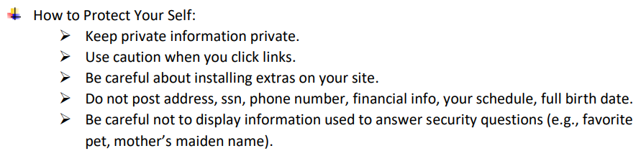

What is the full form of OECD.
The abbreviation OECD stands for:
Organization for Economic Co-operation and Development.
It is an international organization that works to build better policies for better lives, focusing on economic progress and world trade.

What are the competent software engineer [ factors / traits ] to be considered important? Enlist any three.
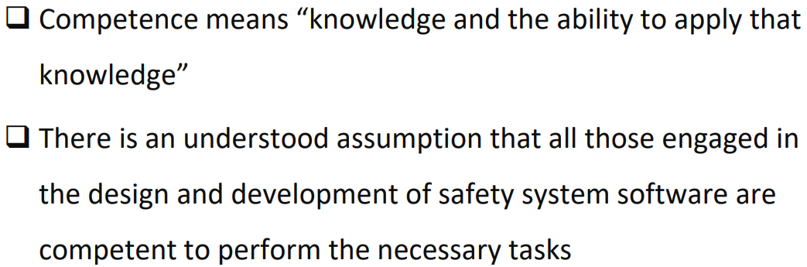
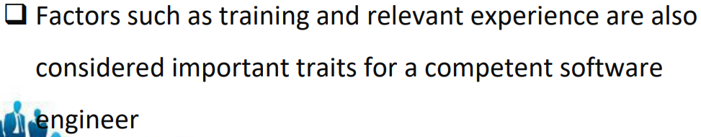

Eavesdropping definition
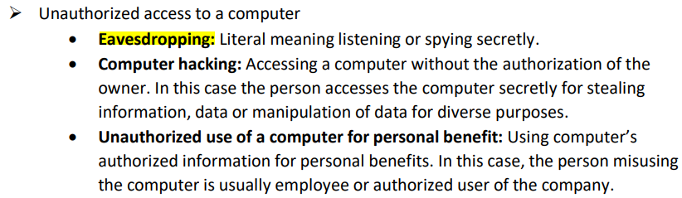

Certification or license
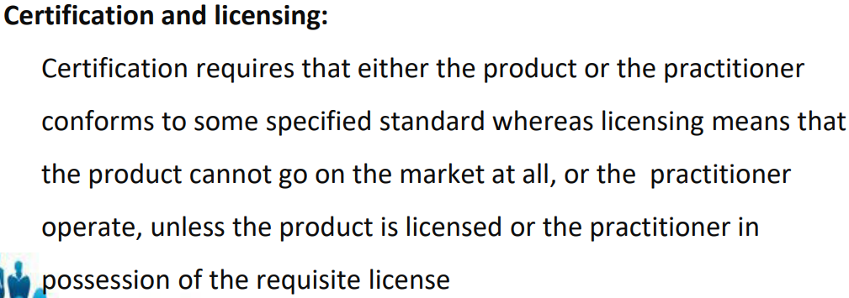

Two categories of infringement of copyrights

1. Direct Infringement
This occurs when someone directly uses copyrighted material without permission, violating the exclusive rights of the copyright holder.
- Examples:
  - Copying and distributing someone else's book, song, or artwork without permission.
  - Uploading copyrighted movies or music to the internet.
  - Using copyrighted images on a website without a license.
- Key feature: The infringer personally commits the unauthorized act, regardless of whether they knew it was protected by copyright.

2. Indirect Infringement
This happens when someone contributes to, facilitates, or benefits from another person’s direct infringement, even if they did not commit the act themselves.
- Subtypes:
  - Contributory Infringement: Knowingly helping or encouraging someone else to infringe (e.g., providing software to illegally download music).
  - Vicarious Infringement: Having control over the infringer and financially benefiting from the infringement (e.g., a company that profits from employees’ illegal use of copyrighted software).
- Key feature: The infringer may not directly violate copyright but is legally responsible due to their role in enabling or profiting from it.

information security means and what type of data used in it
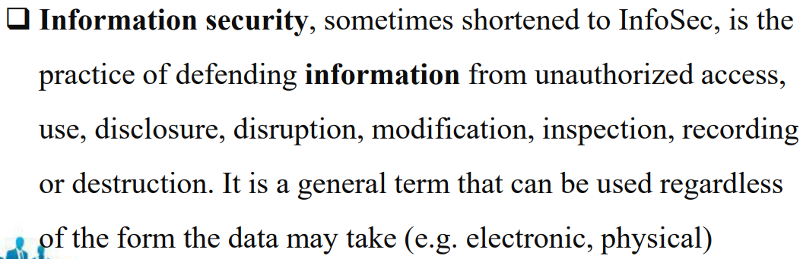

Which of the following information should be posted on the social media websites:
1. Info graphics
2. Webinars
3. Search papers
4. Podcast
5. CNIC number
6. Your address
The following items should be posted on social media:
✅ 1. Infographics – Yes. They are great for sharing informative and visually engaging content.
✅ 2. Webinars – Yes. Promoting or sharing webinars is useful for audience engagement and knowledge sharing.
✅ 4. Podcasts – Yes. Sharing podcast episodes or links is common and effective for growing an audience.

The following items should NOT be posted on social media:
❌ 3. Search papers – Depends. If you mean research papers, then share only if you have permission or if they’re publicly available. Don’t share copyrighted or unpublished academic work.
❌ 5. CNIC number – Absolutely not. This is sensitive personal information and should never be posted online due to identity theft risks.
❌ 6. Your address – Never. Sharing your personal address publicly is a serious privacy and safety risk.

Summary:

Safe to post: Infographics, Webinars, Podcasts
Risky or unsafe to post: CNIC number, Your address
Caution: Research papers (only if you have rights and it's appropriate)

Which intellectual property belongs to the computer program?

Password cracking two types
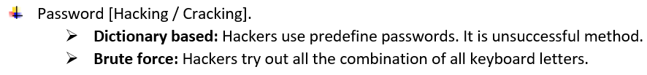

Enlist at least three things which can be delivered to the client as a result of a software contract.
- Documentation – This includes user manuals, technical documentation, API documentation, or installation guides.
- Source Code – The readable codebase of the software, if agreed upon in the contract, for maintenance or future development.
- Software Product or Application – The final executable program or system developed according to the client’s requirements.

For a competent software engineer, which factors/traits are considered important? Enlist any three.
Factors such as training, relevant experience and problem-solving skills are also considered important traits for a competent software engineer.

Which of the following are the advantages of the internet?
- The internet provides a vast array of entertainment options.
- The internet has created new opportunities for cybercrime.
- The internet has made it possible for people to work from home or remote locations.
- The anonymity of the internet has made it easier for people to engage in cyber bullying, harassment and hate speech.
The internet provides a vast array of entertainment options.
The internet has made it possible for people to work from home or remote locations

What are the two categories of infringement in contracts?
- Minor Infringement – A small mistake or failure that doesn’t ruin the whole contract.
- Major Infringement – A big failure that breaks the main purpose of the contract.

Which of the following is true about data protection?
- Protection of information of employees.
- Protection of organization rights.
- Protection of organization repute.
Protection of information of employees.

Threats
